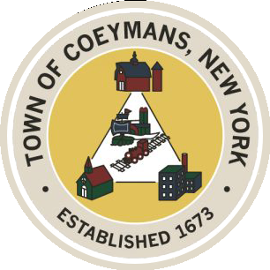

Stephen Donnelly

SUPERVISOR

COUNCIL MEMBERS

Michael J.Stott Linda S.Bruno Stephen J.Schmitt Ronald J.Hotaling

18 Russell Avenue, Ravena, New York 12143

(518) 756-6006 Fax: (518) 756-1991

TOWN OF COEYMANS, NEW YORK

**TOWN BOARD OF THE TOWN OF COEYMANS**

**Town Board Meeting 6:00pm**

***Please silence cell phones while meeting is in progress***

**Date**: October 9, 2025

1. **Call to Order – Pledge of Allegiance**
2. **Members Present**
3. **Public Announcements**
   1. 10/10/25 RCS K-12 Early Dismissal
   2. 10/13/25 Indigenous Peoples Day: **Town Offices closed**
4. **Approval of Minutes**

4.1.Town Board Meeting 9/25/25

1. **Old Business**
   1. Verkada
   2. New Town Office Update
   3. Heidelberg update
2. **New Business**
   1. AGRI Tourism Discussion
3. **Resolutions**

7.1. WVPP

7.2. UV

7.3. Zoning (public hearing)

7.4. Laberge addendum

7.5. Weight restriction (public hearing)

1. **Upcoming Meetings**

8.1. October 22, 2025 – PB/ZBA Meeting @ 7:00 PM

8.2. October 23, 2025 – Town Board Meeting @ 6:00 PM

8.3. November 10, 2025 – PB/ZBA Meeting @ 7:00 PM

8.4. November 13, 2025 – Town Board Meeting @ 6:00 PM

1. **Public Comment**
2. **Adjourn**