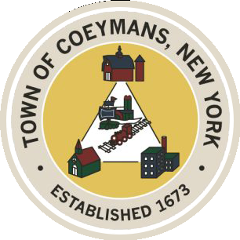

Stephen Donnelly

SUPERVISOR

COUNCIL MEMBERS

Michael J.Stott Linda S.Bruno Stephen J.Schmitt Ronald J.Hotaling

18 Russell Avenue, Ravena, New York 12143

(518) 756-6006 Fax: (518) 756-1991

TOWN OF COEYMANS, NEW YORK

**TOWN BOARD OF THE TOWN OF COEYMANS**

**Town Board Meeting 6:00pm**

***Please silence cell phones while meeting is in progress***

**Date**: September 25, 2025

1. **Call to Order – Pledge of Allegiance**
2. **Members Present**
3. **Public Announcements**
   1. Evening on the Green Concert 10/01/25 Joseph Ishikawa 6pm Riverfront Park
   2. Evening on the Green Concert 10/03/25 Nite Train! 6pm Riverfront Park
4. **Approval of Minutes**

4.1.Town Board Meeting 9/11/25

4.2. Special Meeting Minutes 9/15/25

1. **Supervisor Report**
   1. Supervisor report for August 2025
2. **Department Reports**

6.1. Town Clerk Report for August 2025

6.2. Police Department Report for August 2025

6.3. Building Department Report for August 2025

6.4. Sewer Department Report for August 2025

6.5. Highway Department Report for August 2025

6.6. Liaison Reports

1. **Old Business**
2. **New Business**
3. **Resolutions**

7.1. Police Officer Veeder to Sergeant

7.2. Route 9W Capital Fund

7.3. Laberge Addendum

7.4 September 2025 Abstract

1. **Upcoming Meetings**

8.1. October 6, 2025 – PB/ZBA Meeting @ 7:00 PM

8.2. October 9, 2025 – Town Board Meeting @ 6:00 PM

8.3. October 22, 2025 – PB/ZBA Meeting @ 7:00 PM

8.4. October 23, 2025 – Town Board Meeting @ 6:00 PM

1. **Public Comment**
2. **Adjourn**