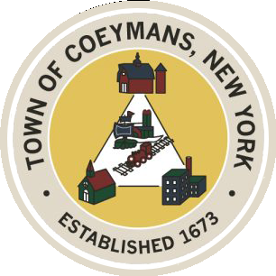

Stephen Donnelly

SUPERVISOR

COUNCIL MEMBERS

Michael J.Stott Linda S.Bruno Stephen J.Schmitt Ronald J.Hotaling

18 Russell Avenue, Ravena, New York 12143

(518) 756-6006 Fax: (518) 756-1991

TOWN OF COEYMANS, NEW YORK

**TOWN BOARD OF THE TOWN OF COEYMANS**

**Town Board Meeting 6:00pm**

***Please silence cell phones while meeting is in progress***

**Date**: September 11, 2025

1. **Call to Order – Pledge of Allegiance**
2. **Members Present**
3. **Public Announcements**
   1. Music Bingo 9/12/25 7-9pm at Rail to River Brewing
   2. Evening on the Green- East Berne Band 9/17/25 6pm at Riverfront Park
   3. Financial Elder Abuse Class 9/22/25 3:30pm at Ravena Senior Projects
4. **Approval of Minutes**

4.1.Town Board Meeting 8/28/25

4.2. Special Meeting Minutes 9/3/25

1. **Old Business**
2. **New Business**
3. **Resolutions**

7.1. Acceptance of Resignation of Police Officer (J. McCanney)

7.2. Hire Part Time Police Officer (M. Patterson)

7.3. Budget Transfer (Parks)

7.4. Budget Amendment (Planning Board)

1. **Upcoming Meetings**

8.1. September 24, 2025 – PB/ZBA Meeting @ 7:00 PM

8.2. September 25, 2025 – Town Board Meeting @ 6:00 PM

8.3. October 9, 2025 – Town Board Meeting @ 6:00 PM

8.4. October 14, 2025 – PB/ZBA Meeting @ 7:00 PM

1. **Public Comment**
2. **Adjourn**